Sequence Diagram

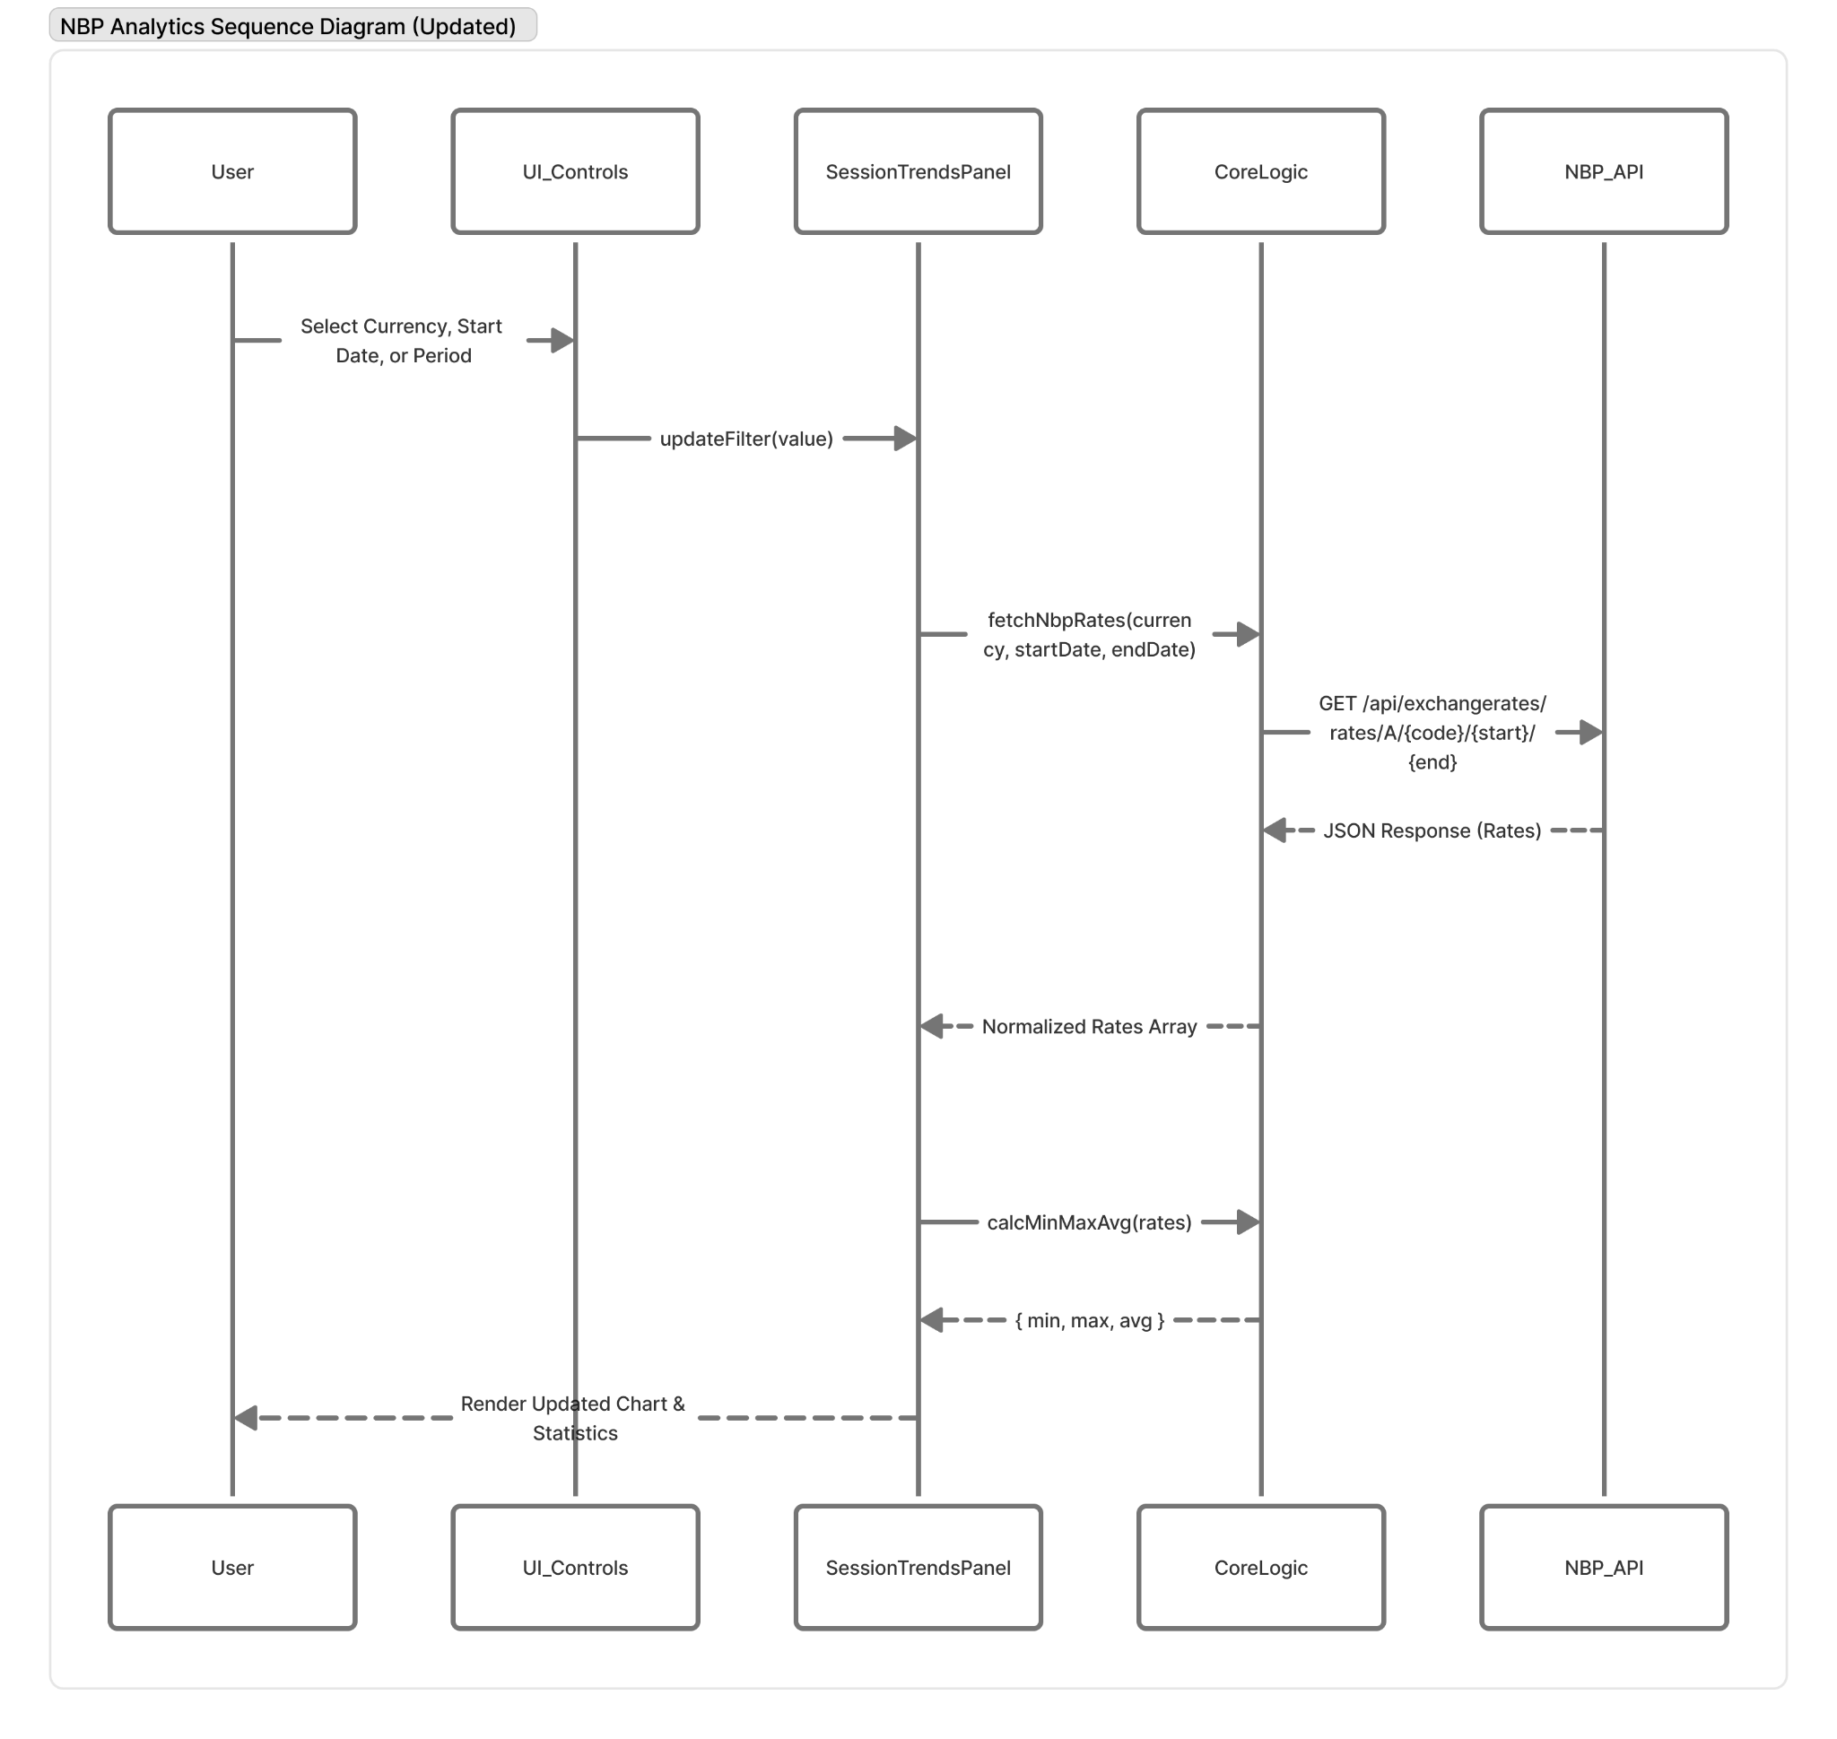

The provided sequence diagram illustrates the data retrieval and processing workflow within the NBP Analytics application. The system executes a linear pipeline encompassing user input, external API integration, data transformation, and interface rendering
The execution cycle follows these primary steps:
- Initialization: The process begins when the user selects a target currency (e.g., EUR or USD) via the CurrencySelect component
- API Request: This interaction is captured by the SessionTrendsPanel, which initiates the data loading phase. It invokes the fetchNbpRates method within the CoreLogic module, which subsequently executes a request to the external NBP API to retrieve historical exchange rates
- Data Normalization: Upon receiving the raw JSON payload, the CoreLogic layer processes the response. It normalizes the dataset - specifically structuring the dates and rate values - before returning the refined data to the panel
- Statistical Computation: The SessionTrendsPanel then updates its internal state. Prior to rendering, the normalized dataset is processed through the calcMinMaxAvg function to compute the required summary statistics.
- UI Rendering: Finally, the user interface re-renders, presenting the updated chart and statistical metrics.

